**DATASCIENCE CAPSTONE PROJECT ON REAL ESTATE (PROJECT-1)**

**BY BONDILI MANISHA SINGH**

**FILES**

** **

**TASKS COMPLETED**

Top 2,500 locations where the percentage of households with a second mortgage is the highest and percent ownership is above 10%..

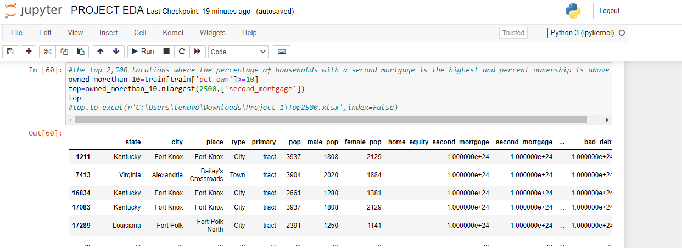

Bad debt

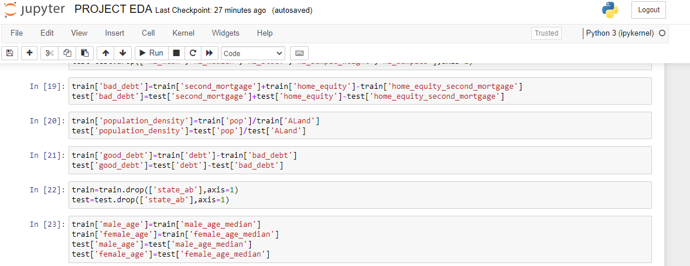

Pie charts (Venn diagram) to show overall debt(% bad and good debt) and bad debt(2 mortgage and home equity loan).

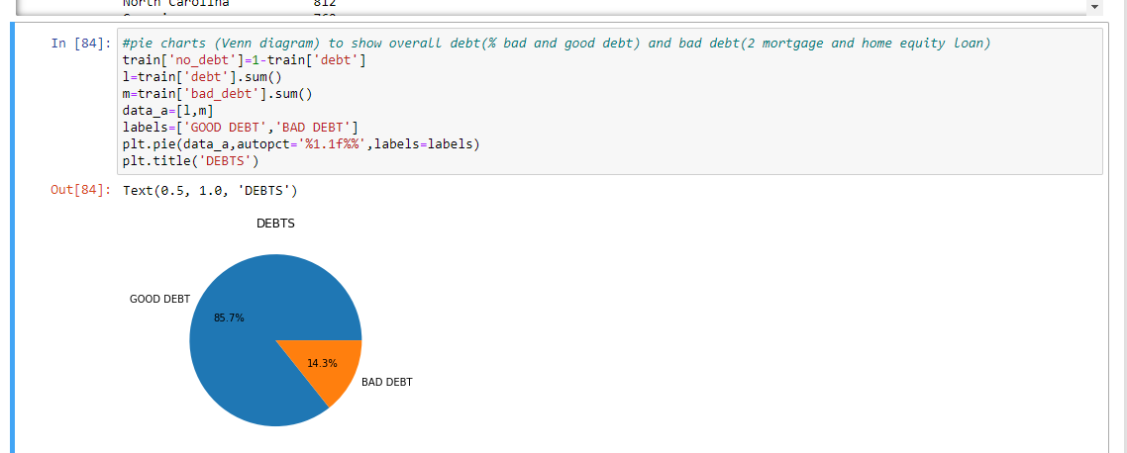

Box and whisker plot and analyze the distribution for 2nd mortgage, home equity, good debt and bad debt for different cities.

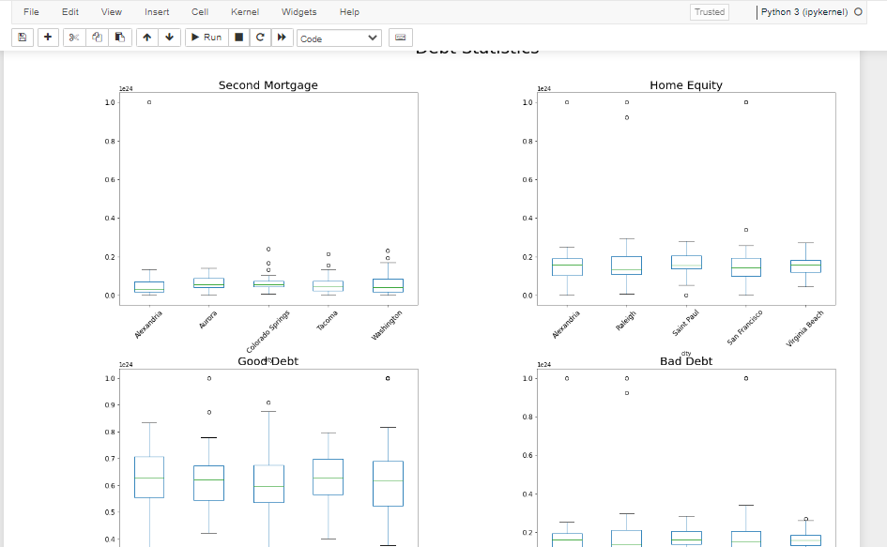

Collated income distribution chart for family income, house hold income and remaining income.

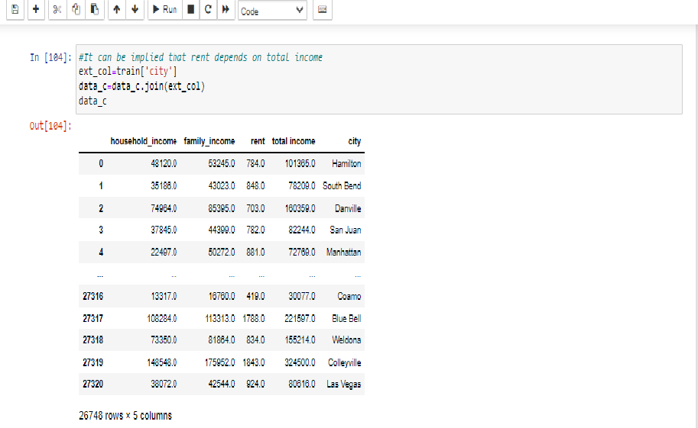

Create bins for population into a new variable by selecting appropriate class interval so that the no of categories (bins) don’t exceed 5 for the ease of analysis. Analyze the married, separated and divorced population for these population brackets. Visualize using appropriate chart type.

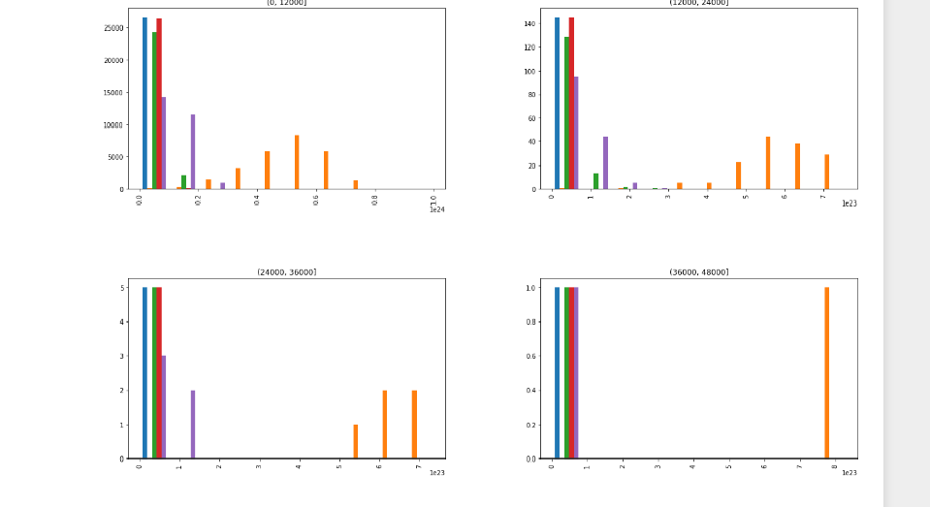

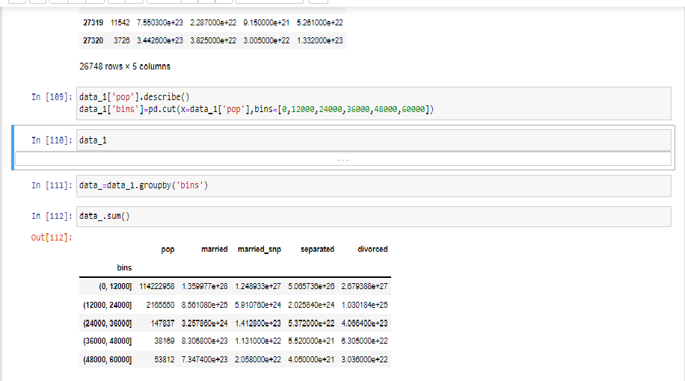

Observations for rent as a percentage of income at an overall level and for different states

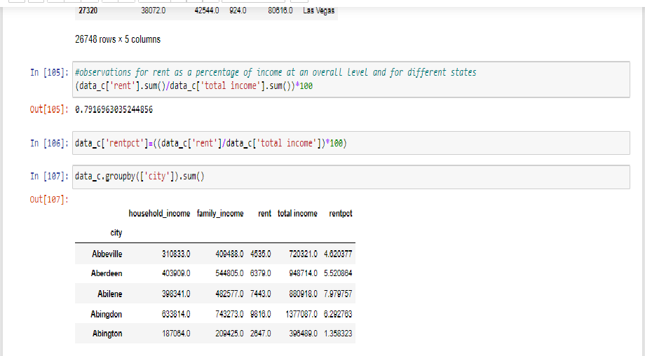

Correlation analysis for all the relevant variables by creating a heatmap, Description of findings

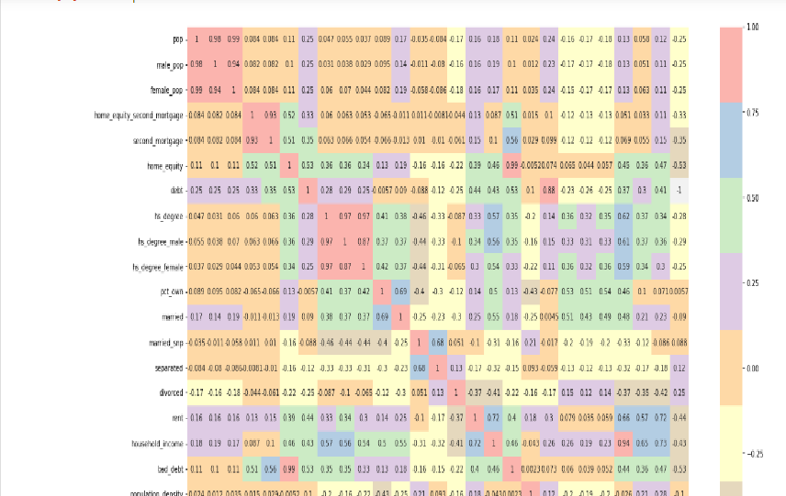

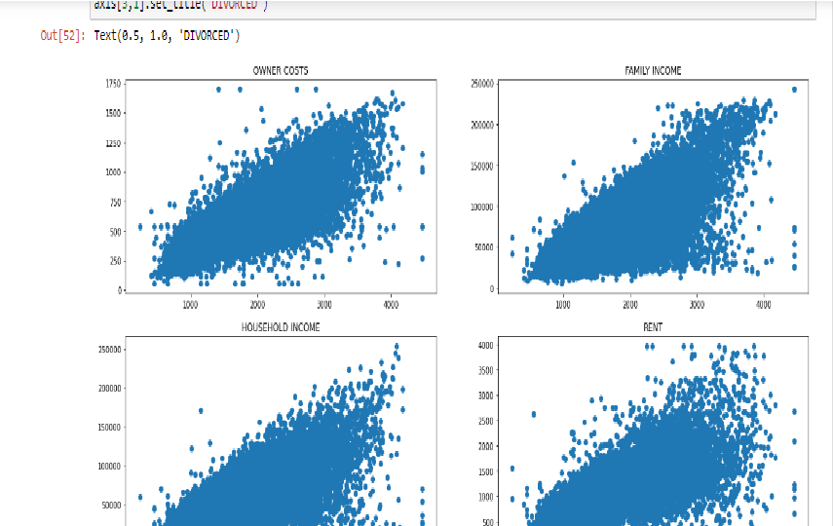

Model Building

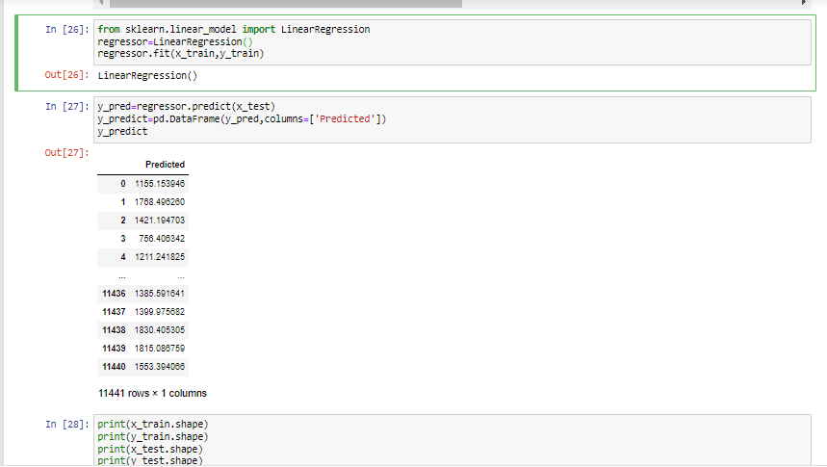

TABLEAU VISUALIZATIONS

